* + 1. **Manual Testing Interviews Question**

1. What is regression testing?

To ensure that the defect, which were fixed by dev. Team in the earlier build cause of fixed defect, remaining functionality are whether working or not in the current build or which test cases has passed in the earlier build, that same test cases has whether passed or failed in the current build.

1. What is re testing? 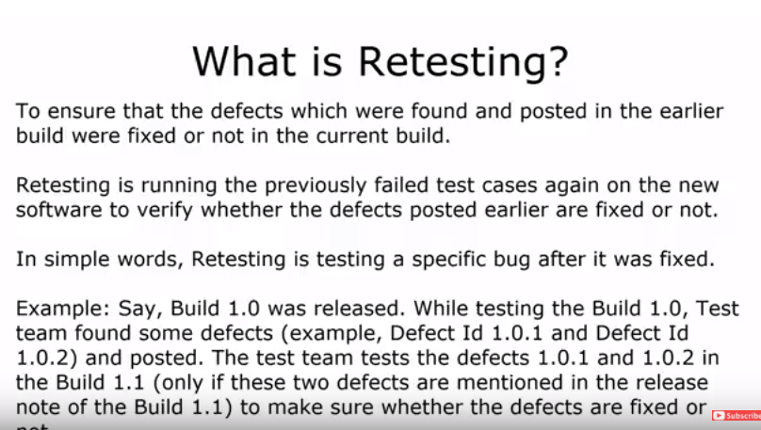We validate in re Testing.

To ensure that the defect which were found by testing team in the earlier build, have been fixed in current build or that test cases which were failed in earlier build same test cases has whether passed or failed in the current build.

What is software testing?

Software testing is a process to evaluate the functionality of the application whether the developed application met the client requirement or not and identify the defects to ensure that the product is defect free and in order to produce the quality product.

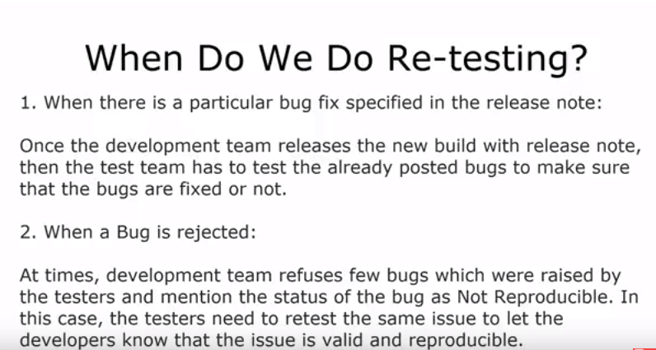

1. When dev. Team releases the new build and testing team start the testing on new build for the application.
2. When testing team given the wrong scenario steps(Actual and Expected) in defect description or summary in that time dev team, have to say ‘Not Reproducible’ and that defect does not exist in current build.
3. What is smoke Testing and sanity testing?
   1. Smoke testing:-Smoke testing is done to make sure that the build we are getting from development team is testable or not. It is also called build verification testing.
   2. Sanity Testing:- Sanity testing is subset of regression testing. Sanity testing is performe when we do not have enough time to do overall regression testing. Sanity testing performs after releasing the build we check major functionally of application are whether working or not.
   3. Smoke testing:-Smoke testing is done to make sure that the build we are getting from development team is testable or not or build is stable to further testing, it is also called build verification testing.
   4. Sanity Testing:-Sanity testing is subset of regression testing. Sanity testing is performing when we do not have enough time to do overall regression testing. Sanity testing performs after releasing the new build we check major functionalities of application whether working or not.
4. When we perform sanity testing?
   1. When we do not have enough time to perform overall regression testing.
   2. After releasing the new build we perform sanity testing on that build
   3. To check major functionalities of the application are working weather fine or not.
5. Difference between Sanity tests and regression testing.

In sanity testing, we check only major functionality of the application but in regression testing, we check each and every functionality of the application.

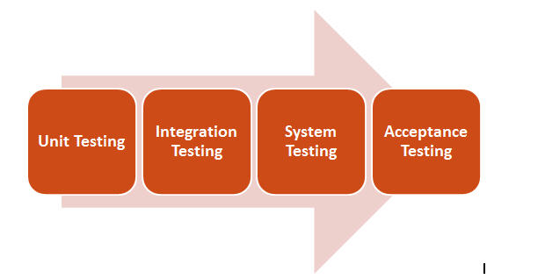

1. What is integration testing?

Integration testing is perform when two or more than two modules are combine, when we check both modules of data is being transferring and navigating properly, integration testing is always done before system testing and after unit testing.

1. What is system testing?

In system testing, we test the both functional as well as non-functional parameters we test each functionality or end-to-end scenarios of the application and check application is meets the client requirement but before doing system testing please keep in mind integration testing must be done, system testing is always done before acceptance testing and after integration testing.

Functional parameters

GUI

Functional

User-friendly

Non-Functional parameters

Performance

Volume

Load

Stress

1. What is UAT testing?

User acceptance testing is performed by the Client to certify the system with respect to the requirements that was agreed upon. This testing happens in the final phase of testing before moving the software application to Market or Production environment, The main purpose of this testing to validate the end to end business flow. It does NOT focus on the cosmetic errors, Spelling mistakes or System testing. This testing is carried out in separate testing env. UAT or staging environment with production like data setup.

1. What is alpha testing and beta testing?

Alpha Testing:- It is the most common type of testing used in software industry. The objective of this testing is to identify all possible issues or defects before releasing it into the market or to the user. Alpha testing is carried out at the end of the software development phase but before the Beta Testing. Still, minor design changes may be made as a result of such testing. It is conducted at the developer’s site. In-house virtual user environment can be created for this type of testing.

Beta Testing:- It is a formal type of software testing which is carried out by the customer. It is performed in **Real Environment**before releasing the product into the market for the actual end users. Beta testing is carried to ensure that there are no major failures in the software or product and it satisfies the business requirements from an end-user perspective. Beta testing is successful when the customer accepts the software.

Usually, this testing is typically done by end-users or others. It is the final testing done before releasing an application for commercial purpose. Usually, the Beta version of the software or product released is limited to a certain number of users in a specific area. Therefore, end user actually uses the software and shares the feedback to the company. Company then takes necessary action before releasing the software to the worldwide.

1. What is exploratory testing?

Exploratory testing means the testing of software without any specific plans or schedules. This is a formal testing process where we don’t have any test cases or test planning documents to test the application. Instead, testers identify the functionality of an application by exploring the application, learning the application, and designing and executing the test plans according to their findings.

1. Explain the steps of bug /defect life cycle?

***Defect life cycle***, also known as***Bug Life cycle*** is the journey of a defect cycle, which a defect goes through during its lifetime. It varies from organization to organization and from project to project.

1. **New:** Whenever testing team found the defect then that defect will be logged into the bug tracking tool and that defect will be marked as a **New.**
2. **Assigned**: Once the testing team logged the defect then QA lead will assigned the defect to concern dev. Team or developer

* Deferred: If developer feels that defect is not on high priority and can be fixed in next release because may be defect have low priority that defect will be marked as a Deferred.
* Rejected: If developer feels that defect is not valid or appropriate or doesn’t meet the requirement that defect will be marked as a Rejected.
* Duplicate: If developer identify that is already created by another QA member r same QA that defect will marked as Duplicate.

1. **Open:**  Once the defect is assigned to dev. team then dev. Team will start the work on that defect.
2. **Fixed**: When developer implement the new code for the defect fixes and release the new build to verify the defect that defect will be marked as a Fixed
3. **Retest:** Testing team will verify that defect got fixed by developer which have been fixed in the current build or release that defect will be marked as a Retest.
4. **Reopened:** If testing team identify that defect got fixed by developer still exist or reproducible then the bug goes through the life cycle once again.
5. **Closed:**Once the bug is fixed, it is tested by the tester. If the tester feels that the bug doesn’t exists in the software, that defect will be marked as a Closed. This state means that the bug is fixed, tested and approved.

# What is test case template explain all fields

1. How to log bug in bug tracking tool?
2. What is functional testing?
3. What is severity and priority?

Severity means how much defect impact on the functionality.

1.Critical (High): No work around and cannot move for further testing such as login button is not working

2.major: Its workaround is there and can be move for further testing such as forget password link

3.minor: its workaround is there and loss of functionality.

Severity is decided by tester.

Priority means how soon bug should be fixed.

1.High: Bug should be fixed immediately cannot be used until defect it is fixed.

2.medium: Bug should be fixed in next release or until high prority defect is not fixed.

3.Low: that bug has no impact on other functionality.

Priority is decided by developer.

1. Tell the high severity and high priority.

Ex: login button is not working, so its should be fixed immediately

1. Tell low severity and high priority.

Ex: Company logo is not implemented

1. Tell high severity and low priority.

Ex: forget password link

1. Tell low severity and low priority

Ex: design issue or UI issue

1. When set the bug status differed?

 The bug changed to deferred state means the bug is expected to be fixed in next releases. The reasons for changing the bug to this state have many factors. Some of them are [priority](http://istqbexamcertification.com/what-is-the-difference-between-severity-and-priority/)of the bug may be low, lack of time for the release or the bug may not have major effect on the software.

1. What is pesticide paradox?
2. What is defect/Bug clustering?

Defect Clustering in Software Testing is based on the Pareto principle, also known as the 80-20 rule, where it is stated that approximately 80% of the problems are caused by 20% of the modules.

1. What are entry exit criteria of sign up page?
2. What is responsive testing?
3. What is test scenario of enquiry form?
4. What is field testing?
5. Difference between SDLC and STLC?
6. What are Non functional testing?
7. What is load testing?

It is a type of non-functional testing and the objective of Load testing is to check how much of load or maximum workload a system can handle without any performance degradation. Load testing helps to find the maximum capacity of the system under specific load and any issues that cause the software performance degradation. Load testing is performed using tools like[JMeter](http://www.softwaretestinghelp.com/jmeter-tutorials/), LoadRunner, WebLoad, Silk performer etc.

1. What is stress testing?
2. What is bottom up integration testing?

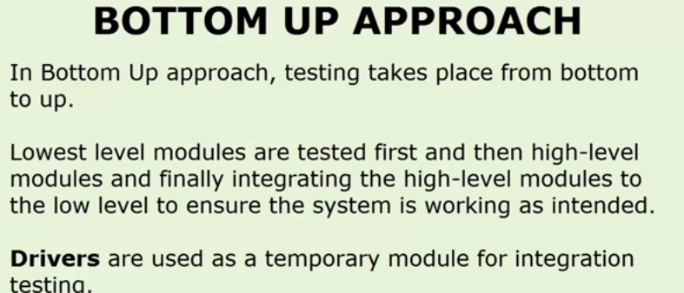

1. What is top down integration testing?

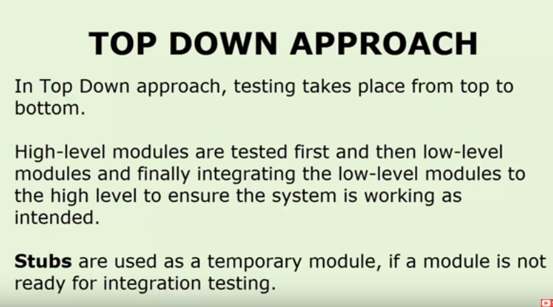

1. What is big bang integration testing?

Combining all modules once and verifying the functionality after completion of individual module testing.

1. What will you do if you logged a bug and developer reply you it’s a reproducible bug, he can’t fix it.
2. Who decides priority of bug?

Priority is generally set by the developer lead or test lead.

1. Who decides severity of bug?

Severity is decided by test engineer.

1. What is bug, defect and fault?
   1. Bug:-A bug is the result of a coding error. An error found in the development environment before the product shipped to the customer.
   2. Fault:- An incorrect step ,process or data definition in computer program which cause the program to perform in an unintended or unanticipated manner.
2. What is bug leakage?

When a bug found by customer or end user and missed by testing team is called bug leakage.

1. What is bug release?

When any build or software is released with known bug is known as bug release. During this the priority and severity of bug will be low.

1. What is ad hoc testing? When should perform ad hoc testing?

The main of ad hoc testing is to break the system. Ad hoc testing is performed without following any process like requirement document, test plan & test cases. It is called ad hoc testing. Ad hoc tests are done after formal testing is performed on the application.

Ad-hoc testing can be done at any point of time whether it’s beginning, middle or end of the project testing. Ad hoc testing can be performed when the time is very limited and detailed testing is required. Usually [adhoc testing](http://toolsqa.com/software-testing/adhoc-testing/) is performed after the formal test execution. Ad hoc testing will be effective only if the tester is having thorough knowledge of the System under Test.

This testing can also be done when the time is very limited and detailed testing is required.

1. Difference between positive and negative testing?

**Positive Testing** :-is testing process where the system is validated against the valid input data. In this testing, tester always check for only valid set of values and check if a application behaves as expected with its expected inputs. The main intention of this testing is to check whether software application does that what it is supposed to do.

Negative testing:- in Negative Testing the system is validated by providing invalid data as input. A negative test checks if an application behaves as expected with its negative inputs. This is to test the application that does not do anything that it is not supposed to do so. Such testing is to be carried out keeping negative point of view & only execute the test cases for only invalid set of input data.

1. What is compatibility testing?

Compatibility Testing is a type of the Non-functional testing. In Compatibility Testing, we check whether your software is capable of running on different hardware, operating systems, browsers, network environments and[Mobile](https://www.guru99.com/mobile-testing.html)devices.

1. What is traceability matrix?

Traceability matrix is a document that maps and traces user requirement with test cases. The main purpose of Requirement Traceability Matrix is to see that all test cases are covered so that no functionality should miss while testing.

1. Explain type of traceability matrix.

There are 3 type of traceability matrix-

* 1. (i)Forward traceability:- This matrix is used to check whether the project progresses in the desired direction and for the right product. It makes sure that each requirement is applied to the product and that each requirement is tested thoroughly. It maps requirements to test cases.
  2. (ii)Backward traceability:- It is used to ensure whether the current product remains on the right track. It maps test cases to requirements. The purpose behind this type of traceability is to verify that we are not expanding the scope of the project by adding code, design elements, test or other work that is not specified in the requirements.
  3. (iii) Bi directional traceability:- This traceability metrics ensures that all requirements are covered by test cases. It analyzes the impact of a change in requirements affected by the defect in a work product and vice versa.

1. What is monkey testing?

**Monkey Testing** is performed randomly, with some random data, without any test cases with the aim of breaking the system.

1. How processes follow in company?

Developers first write code on local server. After that developer upload code on production environment and do unit testing on development environment. After completing unit testing code uploaded in testing envoirnment, where testers test the application on testing environment. If any issue find during testing then developer fixed it in development environment and when all final testing is done. Then we upload code in staging environment. Staging environment.